**UNIFIED DOCUMENT VERIFICATION PLATFORM FOR HIERARCHICAL ADMINISTRATION LEVELS**

**KARTHIKA V[1], ADITHYA J[2], ASWANTH KRISHNAN H R[3], DHANVANTH KUMAR V U[4],HARINANDHAN K P[5]**

[1][2][3][4][5]UG Scholar – B Tech

[1][2][3][4][5] FIRSTYEAR

[1][2][3][4][5] Artificial Intelligence and Data Science Department, KGISL Institute of Technology, Coimbatore

***ABSTRACT***

***Document Verification using a website which can have a huge scope in various fields. A blockchain-based system can be used to issue the digital certificates or documents and to verify it. This helps eliminate reputational risks for an organization as well as improve trust and reliability.***

***There is a need for an automated credential verification system which can reduce the time required for the verification process. Blockchain Technology can be used to reduce overhead and reduce the time taken for document verification from days to mere seconds***

***Email automation is a way to create emails that reach the higher authorities at the right moment without any delay and reduce the time. It is highly efficient and increase the time efficiency.***

***It plays a major role in reducing the manual work and to increase the efficiency in the verification of the document. Here we are using email automation in this website such that we can also send the emails to the respective mail id given by the users automatically without composing it. By using the given icons in this website we can upload it and the***

***higher authorities will be able to view it and can verify the authentication and reliability of the documents easily***.

**INTRODUCTION**

Document verification techniques are employed by businesses and institutions to ensure that documents such as identity documents, financial documents and healthcare records are authentic and valid. With accurate document verification, businesses can verify customers, vendors, employees and so much more. There are two primary methods of document verification: manual and automated. Businesses often choose between these options based on their specific needs and preferences.

Automated document verification often considered the superior of the two, utilizes technologies like AI to verify documents faster in scale and with lower error rates. With AI-powered document verification, businesses can spend less money on hiring people to perform Difficult tasks and reduce the loses and helps to reduce the human-made manual errors, and save money overall.

In this project we are creating a website and we can access it by log in option. The individual will upload the document in the upload icon. By listing the mail id of the higher authorities we can automatically send the document to them to get their approval by using the email automation program. In this way we can verify our documents like author card and we can also upload scholarship forms. It is also applicable in many industries like medicine, business, IT and so on.

**KEYWORDS:**

***Document verification, Document verification automation, Mail automation, Verification protocol, Document verification workflow, Digital document verification***

**EXISTING SYSTEM:**

The article document detection in python is mainly about document identification using image processing using open cv in it. It is one of the best document detector as I have seen.

To use this we will need to install some packages which is not a default in python library.

This code is posted in Medium and the code can be seen in the repository in Github by using the link in reference.

Document detection is basically extracting a document from an image. Machine learning and image processing are two common approaches to do this.

Document detection is basically extracting a document from an image. Machine learning and image processing are two common approaches to do this.

Here, we use pixel manipulation techniques to detect the document.

Steps involved is as follows

* Pre-processing image to enhance document.
* Finding document extraction points in the image. Quadrilaterals are the extraction points in this article.
* Extracting the document from the points.
* Post processing to correct distortions and imperfections.

The end goal is to get a clear and usable document and the Pre-processing is done to help achieve that goal. Processing high-resolution images are quite resource intensive and also the amount of noise in an image depends on the hardware and the condition it was captured in.

Images captured in poor lighting tend to be very noisy and causes the distortion of images which reduces the clarity so precaution is needed the threshold function is done by OpenCV as Otsu Thresholder is used for binarization.

Extraction points are points on the perimeter of the document which will be used to extract it and the image will be show. This will help us to get the clear image of the document which will be used to find the authentication and the feasibility of the document through the external library we installed for this program .

**PROPOSED METHODOLOGY**

**D**ocument Verification is a critical process where businesses, government agencies, and financial institutions verify the authenticity and validity of documents presented to them. Email automation works to send emails automatically to the targeted person by making full use of technology and coding knowledge perfectly like python.

The goal is to confirm that a document is genuine, unaltered, and not counterfeit in any way and to ensure authentication and reliability. In document verification we can verify documents without any manual work by using soft copies only

The workflow of this website is that after the login page we can upload our details and then we can upload a file or a document and when we input the mail id of the higher authorities the automation program will be

triggered and the email will be sent and their response will also be sent to us.

**IMPLEMENTATION**

Digital document in this application helps in authentication and also to validate the electronic documents which is to be given by the user by the consumers. The login is the first step in this program which will lead to the next slide or a webpage where there will be many options like upload, verify ,delete and team

The verification process is a very straightforward process which works on collecting the data from the

Doclock is a website which is used to send the documents uploaded by the users to the respective higher authorities through email automation such that they will be able to verify the data from it. The mail automation is done by uploading the document and the automation program will send the document to the respective mail ids in it as it acts as a trigger.

Here to let the receiver know that who sends it we upload our name, email id, class such that they won’t ignore it because sometimes we will consider messages as spam if there is no relevant knowledge about it so we are implementing it in our website.

This website is exclusive for a private organization or and institution as to ensure privacy and also to improve security in these sectors.

Consumers as the origin and it sends this document to the respective higher authorities using email automation.

The authorities will check the document by clicking the link. This link will redirect them to the verify option in the website such that after verification they will respond to it after reviewing them.

The problem unified document verifying platform for verifying document using email automation can be done by using the programming language python. A web page is created using HTML and CCS for styling and to layout the web page and also to use image or a video as the background image in the webpage.

We are using this web page to get approval from the higher level officers in various industries and also in various Hierarchical Administration Levels, the authorities may be of any sector like he may be a dean manager, principle, Head of the department, Administrator officer, and managing director, marketing officer

The main goal of this website is to reduce the manual work and to increase the time efficiency in various fields such as medicine, Institutions, schools and also in IT fields. It may seem simple but it plays a major role in increasing the time efficiency and reduce the work of people.

Let us see the workflow of this program in the following flowchart. Afte the verification the mail will be redirected to the sender to mail the verification result of the document

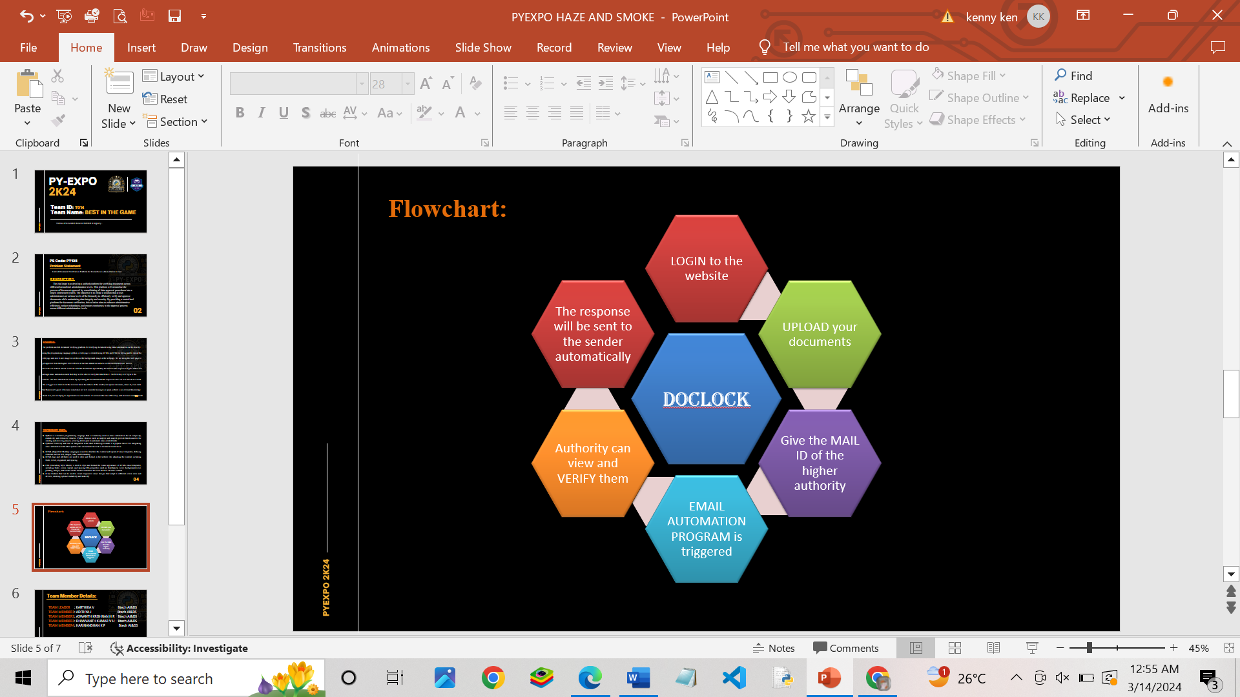

**TECHNOLOGY**

Python is a versatile programming language that is commonly used in email automation for its simplicity, readability, and extensive libraries. Python libraries such as smtplib and imaplib provide functionalities for sending and receiving emails, allowing developers to automate email-related tasks. Python's flexibility and ease of integration with other technologies make it a popular choice for integrating email automation with other systems like our website doclock in document verification.

Python is often used for backend scripting and integration in email automation, while HTML and CSS are essential for creating visually appealing and functional email templates. Together, these technologies enable businesses to automate email campaigns, deliver personalized content, and engage with their audience effectively.

HTML (Hypertext Markup Language) is used to structure the content and layout of email templates, defining elements such as text, images, links, and formatting.

HTML tags and attributes are used to style and format in the website like adjusting the content, including the time efficiency in various fields and also used to adjust the format in the website like adjusting the content including fonts, colors, alignment and spacing.

Inline CSS (Cascading Style Sheets) can be used within HTML email templates to apply custom styles and design elements, such as backgrounds, borders, and padding.HTML email templates must adhere to best practices and coding standards to ensure proper rendering and display across various email clients and devices.

CSS (Cascading Style Sheets) is used to style and format the visual appearance of HTML email templates, including fonts, colors, layout, and spacing.CSS properties such as font-family, color, background-color, padding, margin, and border can be used to customize the look and feel of email content. It has features that can be used to create responsive email designs that adapt to different screen sizes and devices, ensuring optimal readability and usability.

CSS properties and selectors are applied to HTML elements within email templates to control their appearance and behavior. Inline CSS is commonly used in HTML email templates to ensure compatibility and consistency across different email clients and devices, as external stylesheets are often not supported.

Flask is primarily used for building web applications, ranging from simple static websites to complex dynamic web applications. It provides tools and utilities for handling HTTP requests, routing, template rendering, and interacting with database.

RESTful API Development: Flask is well-suited for developing RESTful APIs (Application Programming Interfaces) that expose functionality and data for consumption by other applications. It provides features such as route decorators, request parsing, and response formatting, making it easy to create API endpoints for performing CRUD (Create, Read, Update, Delete) operations. Microservices Architecture: Flask is commonly used in microservices architecture, where applications are composed of small, independent

services that communicate with each other over HTTP or other protocols.

Each Flask application can represent a microservice, providing a lightweight and scalable solution for building distributed systems. Prototyping and Proof-of-Concept Development: Flask is often used for rapid prototyping and proof-of-concept development due to its simplicity and flexibility. Developers can quickly create and test ideas, iterate on designs, and demonstrate functionality without the overhead of more complex frameworks.

In MySQL, a user is an account that you can use to connect to the database. Each user has certain privileges that define the user’s abilities to interact with the database. A role is a named collection of privileges that can be assigned to users. Using roles helps in assigning predefined privileges to users conveniently. MySQL 8 supports a strong password encryption plugin, which this command utilizes to set the user’s password with the SHA-2 encryption mechanism.

MySQL allows administrators to limit the resources a user can utilize, preventing overuse of database resources.The privileges granted to a MySQL account determine which operations the account can perform. MySQL privileges differ in the contexts in which they apply and at different levels of operation:

Administrative privileges enable users to manage operation of the MySQL server. These privileges are global because they are not specific to a particular database.Database privileges apply to a database and to all objects within it. These privileges can be granted for specific databases, or globally so that they apply to all databases.

MySQL provides Privileges for database objects such as tables, indexes, views, and stored routines can be granted for specific objects within a database, for all objects of a given type within a database (for example, all tables in a database), or globally for all objects of a given type in all databases.

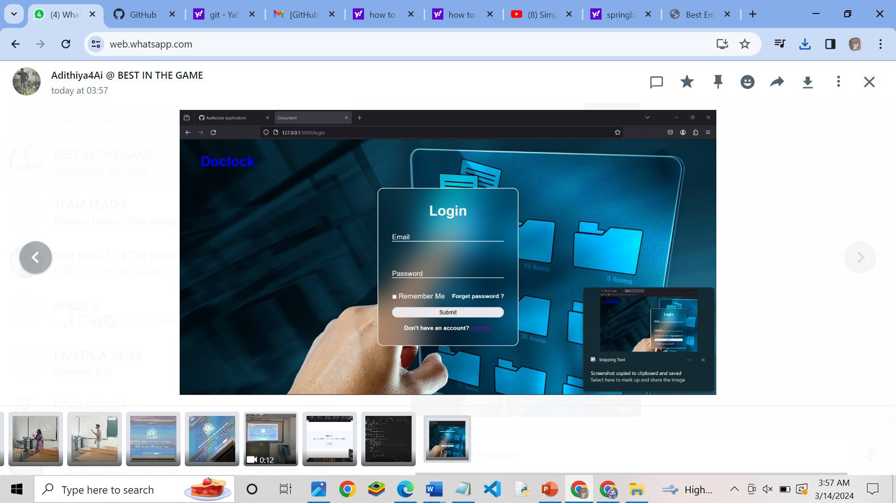

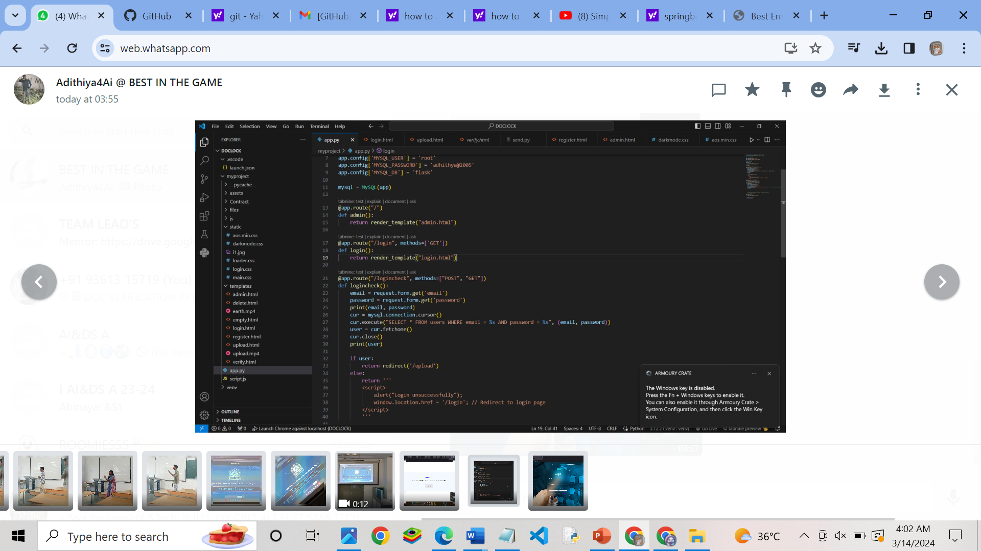

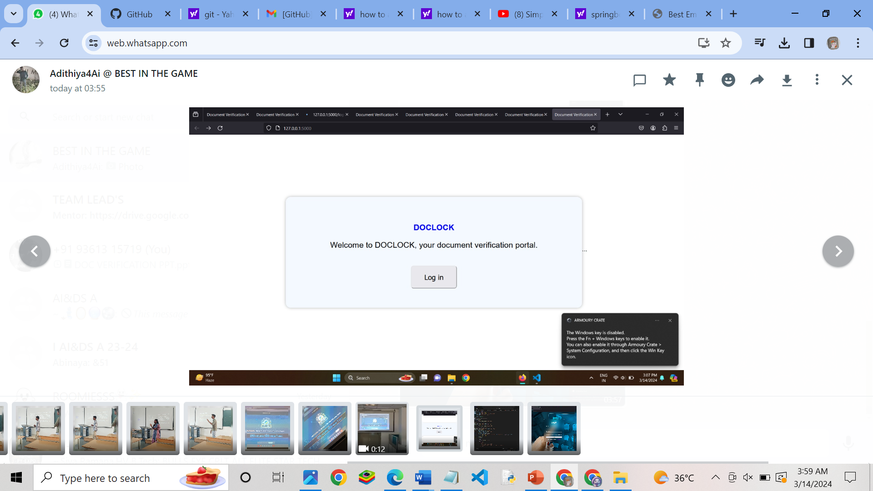

**REFERENCE:**

[3] C. Lakmal, S. Dangalla, C. Herath, C. Wickramarathna, G. Dias and S. Fernando, "IDStack — The common protocol for document verification built on digital signatures," 2017 National Information Technology Conference (NITC), Colombo, Sri Lanka, 2017, pp. 96-99, doi: 10.1109/NITC.2017.8285654.

([IDStack — The common protocol for document verification built on digital signatures | IEEE Conference Publication | IEEE Xplore](https://ieeexplore.ieee.org/document/8285654))

[3] S. S. Sambare, U. Pathak, V. Sonavane, M. Gadiya and S. Musale, "Document Verification System and Validation Against QR Codes," 2023 7th International Conference On Computing, Communication, Control And Automation (ICCUBEA), Pune, India, 2023, pp. 1-5, doi: 10.1109/ICCUBEA58933.2023.10392059.

### ([Document Verification System and Validation Against QR Codes | IEEE Conference Publication | IEEE Xplore](https://ieeexplore.ieee.org/document/10392059))

### [3] S. Bhosale, R. Dhumal, V. Patkar and T. P. Singh, "Use Of RPA For Email Automation With Salesforce Integration," 2023 IEEE 5th International Conference on Cybernetics, Cognition and Machine Learning Applications (ICCCMLA), Hamburg, Germany, 2023, pp. 140-144, doi: 10.1109/ICCCMLA58983.2023.10346663.

### ([Use Of RPA For Email Automation With Salesforce Integration | IEEE Conference Publication | IEEE Xplore](https://ieeexplore.ieee.org/document/10346663))

[3] D. S. R, K. G, K. M and V. K. V, "Digital Documents Verification System," 2022 International Conference on Computer, Power and Communications (ICCPC), Chennai, India, 2022, pp. 389-392, doi: 10.1109/ICCPC55978.2022.10072252.

### ([Digital Documents Verification System | IEEE Conference Publication | IEEE Xplore](https://ieeexplore.ieee.org/document/10072252))

### [3] G. Jagnade, S. Sable and M. Ikar, "Streamlining Email Workflow: Empowering Users with Voice Recognition Technology and Website-Email Autometa Solutions," 2023 14th International Conference on Computing Communication and Networking Technologies (ICCCNT), Delhi, India, 2023, pp. 1-8, doi: 10.1109/ICCCNT56998.2023.10307334.

### ([Streamlining Email Workflow: Empowering Users with Voice Recognition Technology and Website-Email Autometa Solutions | IEEE Conference Publication | IEEE Xplore](https://ieeexplore.ieee.org/document/10307334))

### [1] S. Ghalme, K. Shelke, R. Kadam and U. Tupe, "Automated Emails and Data Segregation using Python," 2023 International Conference on Sustainable Computing and Smart Systems (ICSCSS), Coimbatore, India, 2023, pp. 1701-1705, doi: 10.1109/ICSCSS57650.2023.10169850.

### ([Automated Emails and Data Segregation using Python | IEEE Conference Publication | IEEE Xplore](https://ieeexplore.ieee.org/document/10169850))

[3]G. Premalatha and S. Abinaya, "An Effective Implementation of Vehicle Document Verification Using Genetic Algorithm," 2021 International Conference on System, Computation, Automation and Networking (ICSCAN), Puducherry, India, 2021, pp. 1-6, doi: 10.1109/ICSCAN53069.2021.9526394.

([An Effective Implementation of Vehicle Document Verification Using Genetic Algorithm | IEEE Conference Publication | IEEE Xplore](https://ieeexplore.ieee.org/document/9526394))

[3]R. Jain and D. Doermann, "VisualDiff: Document Image Verification and Change Detection," 2013 12th International Conference on Document Analysis and Recognition, Washington, DC, USA, 2013, pp. 40-44, doi: 10.1109/ICDAR.2013.17.

([VisualDiff: Document Image Verification and Change Detection | IEEE Conference Publication | IEEE Xplore](https://ieeexplore.ieee.org/document/6628582))

**CONCLUTION**

The given problem statement is solved by creating a webpage with certain futures like email automation with HTML and CSS as frontend and python as a programming language. The database used here is MySQL and flask is also installed. Email automation plays a core part in this program.

Let us explain about it in detailed way with real time experience. Consider that there is a HR sitting in his office room reviewing the documents. The documents are from various aspects like recruitment, training, development and performance management. Just consider ourself in that situation, I am sure that we will feel frustrated and mentally exhausted from the work in front of us. This app will help the HR to review it easily by using the application through which the document uploaded can be verified. This make the employees to send mails automatically without any manual work.